Name: ___________________________________________________ Date: _____________
Geometric Probability Day #2- HW
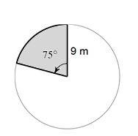
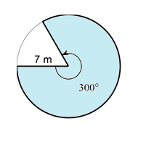
Find the area of both regions and then find the probability that a point chosen at random lies in the shaded region. Round your answers to the nearest tenth.
1. 2.

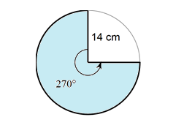
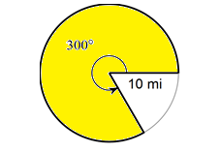
3. 4.

5. 6.

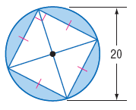
7. 8.

