Name: ___________________________________________________ Date: _____________

**Geometric Probability HW#1**

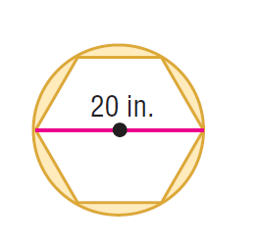Find the area of both regions and then find the probability that a point chosen at random lies in the shaded region. Round your answers to the nearest tenth.

10km

1. 2.

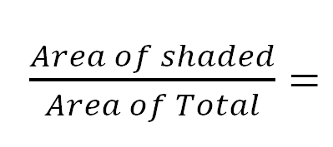

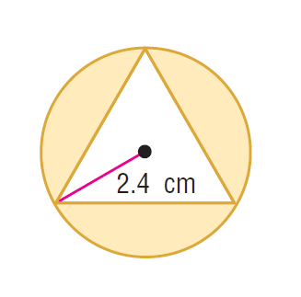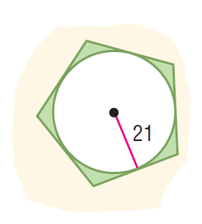

3. 4.





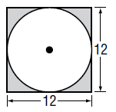5.



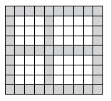

6.



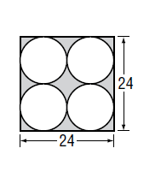

7.

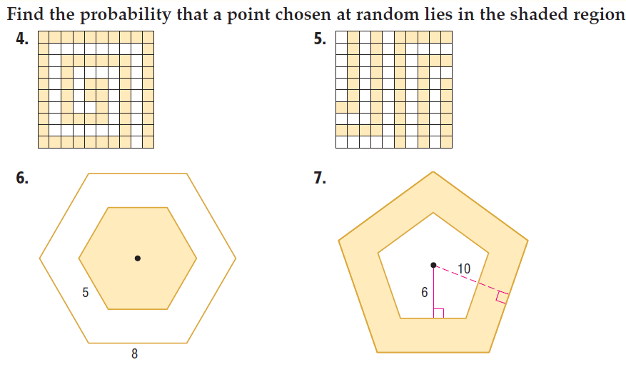

8.