Name: __________________________

**Area Test Review**

Directions: Show all work and attempt all questions for credit!

For # 1-6, find the **perimeter** and **area** of each parallelogram. Keep answer in *exact* simplest form- simplify all radicals.

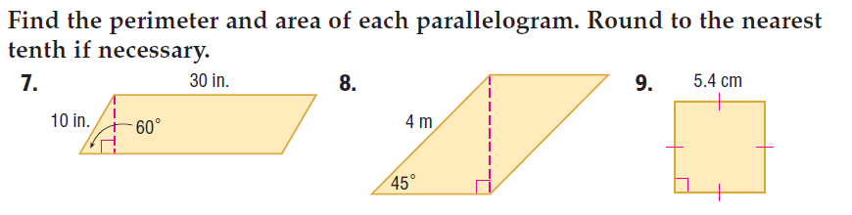

1.  2. 3.

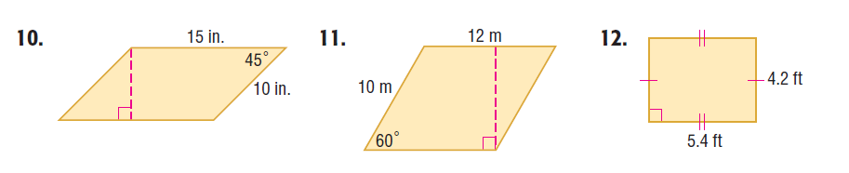



4. 5. 6.

For # 7 – 12, find the **area** of each figure. Round to the nearest tenth if necessary.

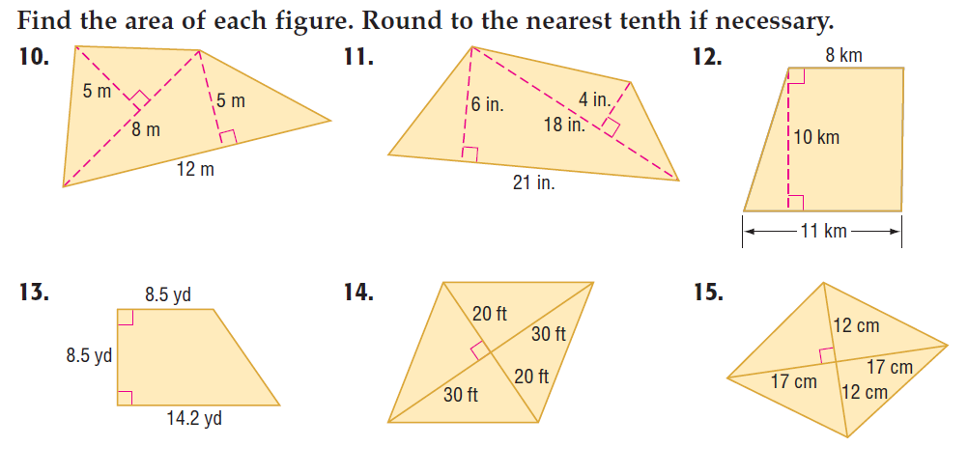

7. 8. 9.



10. 11. 12.

For #13-16, given the coordinates of the vertices, determine whether the figure is a square, a rectangle, or a parallelogram. (You may want to graph it!) Then find the **perimeter** and **area** of TVXY.

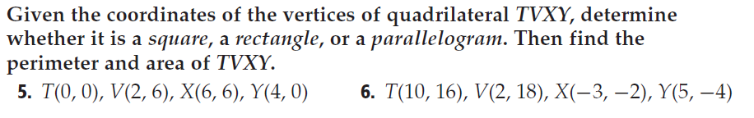

13. 14.

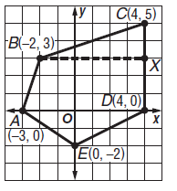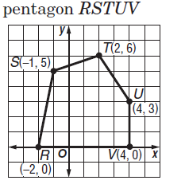

15. 16.

For # 17 – 22, find the **area** of each figure or shaded region. Round to the nearest tenth if necessary.

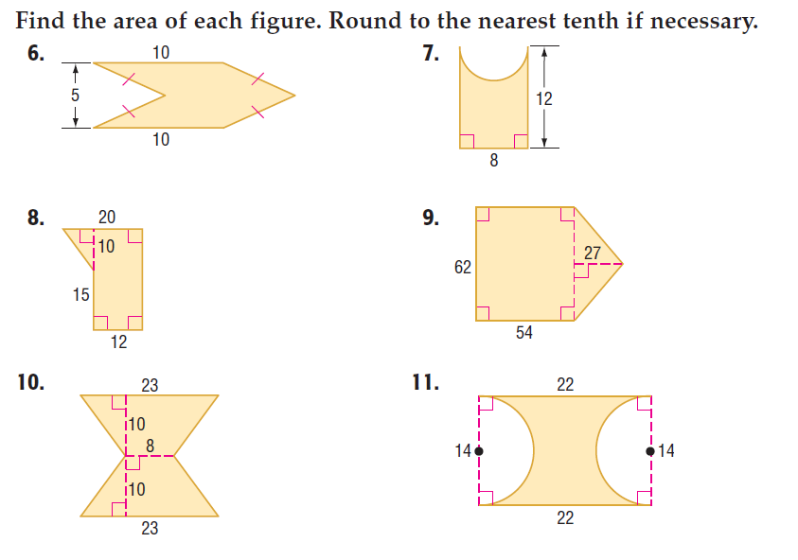

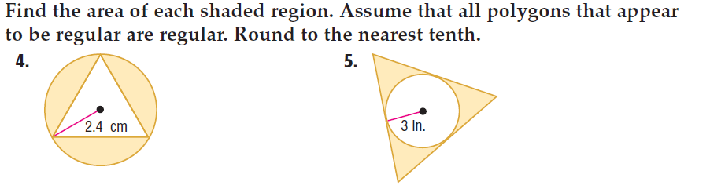17. 18. 19.





20. 21. 22.

For # 23 – 28, find the **area** of each REGULAR polygon. Simplify each answer- simplify radicals!!!!!!

23. Octagon with P = 72in. 24. Square with P =

25. Square with apothem = 12 in. 26. Hexagon with apothem = 24cm

27. Triangle with side length=15.5 in. 28. Octagon with side length= 10km.

For # 29 – 32, find **the probability** that a point chosen at random lies in the shaded region.

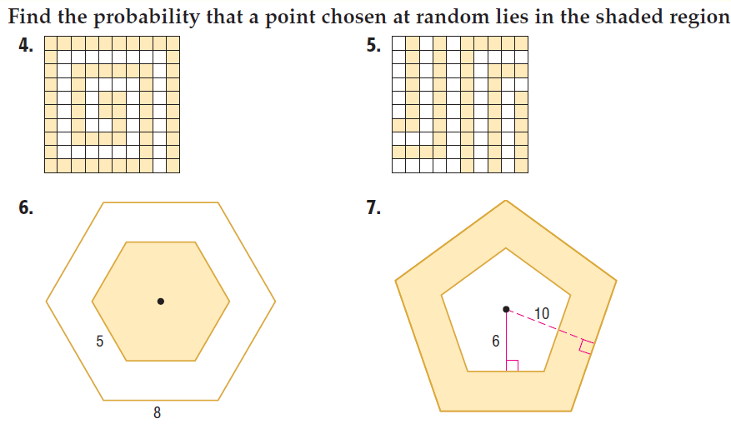

29. 30.

31. 32.

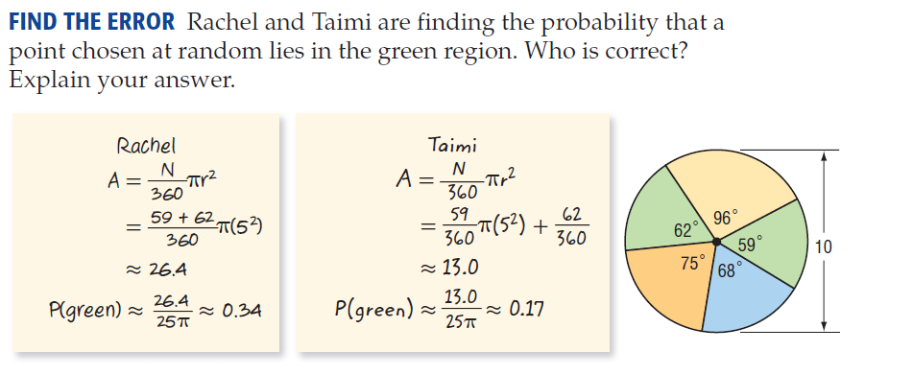

33.

Green

Yellow

Red

Blue

Green

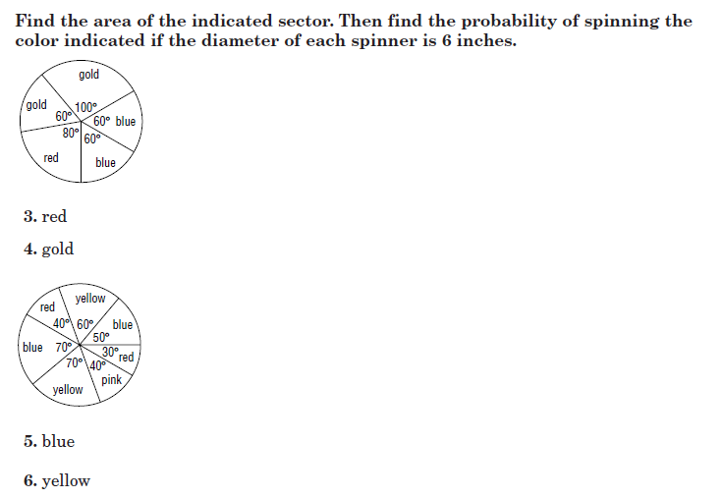Find the **area** of the indicated sector***. Then*** find the **probability** of spinning the color indicated if the diameter of each spinner is 6 inches.

Use for problems

#34 & 35

34. Red 35. Gold

36. Yellow 37. Blue 38. Pink

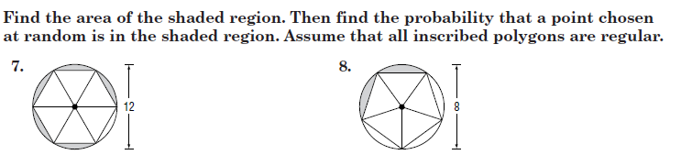

39. 40.

Find the **area** of each circle given the circumference. Leave in terms of , THEN use 3.14 to find the decimal form.

41. 34 42. 17 43. 54.8 44. 91.4

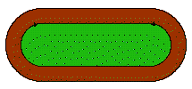45. A running track is shaped like a rectangle with a semicircle on each of the shorter sides. The width across the field is 40feet and the length is 3 times the width. The width of the track is 16 ft across. Find the area of field and find the area of the track. Round each answer to the nearest hundredth.

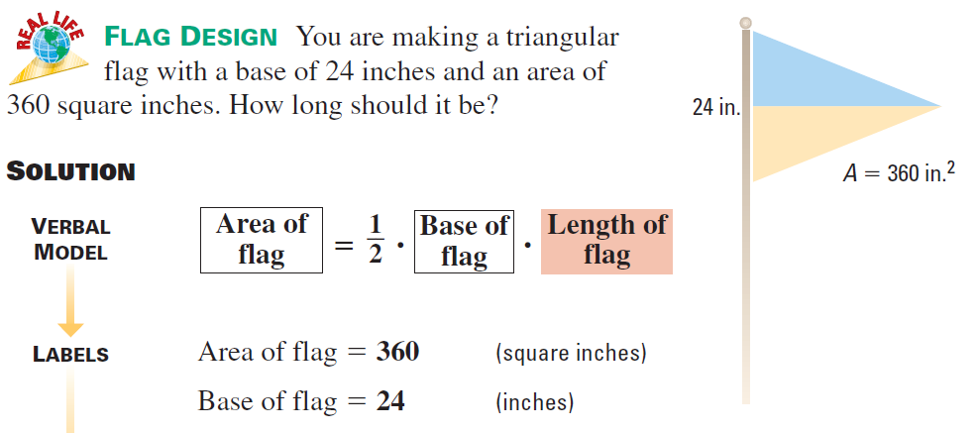46. You are making a triangular flag with a base of 24 inches and

an area of 360 square inches. How long should the flag be?

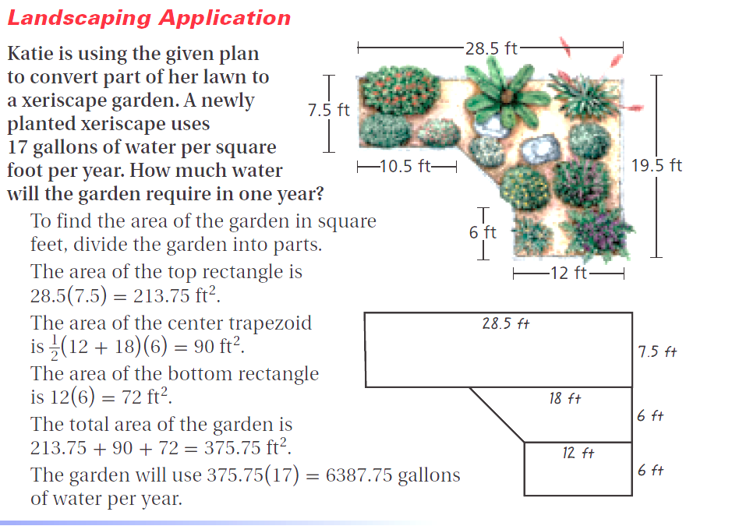**47.** Katie is using the given plan to convert part of her lawn to a xeriscape garden. A newly planted xeriscape uses 17 gallons of water per square foot per year. (a) Find the area of her garden (round to the nearest hundredth). (b) How much water will the garden require in one year? (c) The lawn that Katie is replacing requires 79 gallons of water per square foot per year. How much water will Katie save by planting the xeriscape garden per year?

(a) _______________

(b) _______________

(c) _______________

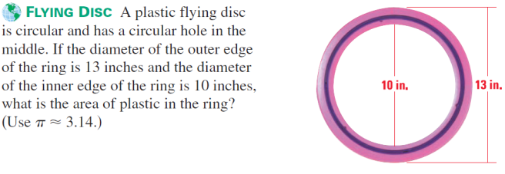**48.** A plastic flying disc is circular and has a circular hole in the middle. If the diameter of the outer edge of the ring is 13 inches and the diameter of the inner edge of the ring is 10 inches, what is the exact area of the plastic ring?

49. You have a part-time job at a school. You need to buy enough grass seed to cover the school’s soccer field. The field is 50 yards wide and 100 yards long. The instructions on the seed bags say that one bag will cover 5,000 square feet. How many bags do you need?

50. Robert and Jarod are painting a stage backdrop for a play. The paint they are using covers 90 square feet per quart. How many quarts of paint should they buy to paint the figure below?

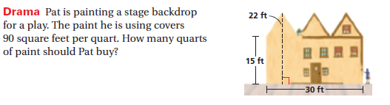

____________ Quarts

51. skip

52. Mrs. Faehner will be tiling the area labeled tile, fireplace and hearth. She will be putting new carpet down in the family room and hardwood floors in the kitchen. She only has $5000 for her rennovation budget. (a) Find the area needed for EACH MATERIAL. (b) If the woodflooring costs $10 per square foot, the tile costs $3 per square foor and the carpet costs $3.30 per square foot, does your assistant principle have enough money (with 6% sales tax) to complete this rennovation? Show all work.

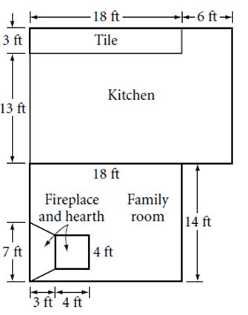

53. Mr. Jones wants to paint the side of his house. To buy paint, he must know

The area of the side of the house he needs to paint. What is the area of one side   
of Mr. Jones’ house?



54. Ms. Labadie is making a giant sign in the shape of a raffle ticket with the given

dimensions in the figure. Find the area in which the sign will cover.

55. An interior designer created the kitchen plan shown. The countertop will be constructed of colored concrete.   
(a) What is the total surface area? (b) If concrete countertops 1.5 inches thick cost $85 per square foot, what will the total cost (with sales tax) be for this countertop?

